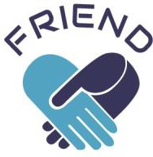

1st Newsletter - August 2024

Launch of the FRIEND Project: promoting friendships for the wellbeing of people over 65

We are pleased to announce the launch of the European FRIEND project, funded by the Erasmus+ programme. The project involves a partnership comprising the Netherlands, Italy, Spain, Portugal, and Poland.

# Objectives of the FRIEND Project

The FRIEND project aims to develop an experiential training programme designed to enhance the social skills of older adults in order to prevent and/or reduce the risk of social isolation and loneliness. By promoting social inclusion and the participation of people over 65, the project aims to improve their overall wellbeing.

Indeed, having friendships plays an important role in promoting personal wellbeing at all ages. In later life, being able to rely on friendships helps individuals cope with and process significant life transitions such as retirement or widowhood and adapt to new roles. Despite the numerous advantages of having friendships, older adults often experience strong feelings of loneliness or feel they do not receive the support and closeness they need from their friends.

# Inspiration from the FEP Programme

The FRIEND programme draws inspiration from the Friendship Enrichment Programme (FEP) developed and tested in the Netherlands by Nan Stevens (2001). The FEP programme consisted of 11 sessions that included a theoretical part followed by practical and experiential exercises; each session concluded with some exercises to be carried out at home before the next session. The FEP programme was tested on a group of 40 women divided into groups of 8-10 participants, aged between 54 and 73 years. The experimentation showed that most participants were able to develop new friendships or improve existing ones and significantly reduce their loneliness. Subsequently, a completely online version of the programme was tested (Bouwman et al., 2016) involving 239 people of both sexes, over 50. The online FEP programme proved effective in reducing both social and emotional loneliness, but there was a high drop-out rate (66% and 72%), likely due to the solely online mode.

The FRIEND project therefore aims to develop a version of the programme that combines the benefits of the first entirely face-to-face version with those of the online version, favouring maximum engagement of the target group through a blend of in-person and online activities.

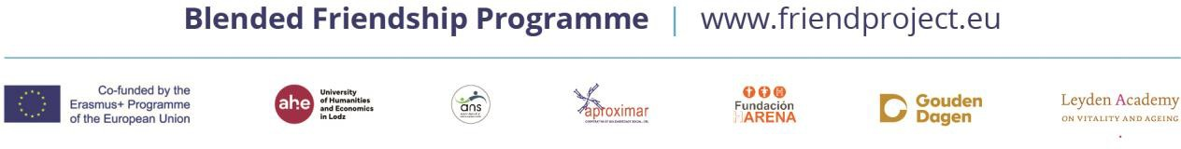

# Train-the-Trainer Programme

In addition to the FRIEND programme, the project also aims to develop training dedicated to professionals and interested volunteers, enabling them to implement the FRIEND programme and acquire the necessary knowledge and skills.

# Focus Groups

In these early months of the project, focus groups have been conducted involving older adults and professionals from five European countries, with a dual objective:

* investigate the real needs and interests of older adults to develop a programme truly tailored to their needs and interests;
* investigate the training needs of professionals for the development of the train-the-trainer programme.

The focus groups revealed a broad interest from both older adults and professionals in the concept of friendship. It was considered very innovative to have a programme that talks about friendship.

# Next Steps

In the coming months, the project partners will work on developing the programme, guided by the key points that emerged during the discussion groups.

To find out more and stay updated on the next steps of the project visit our website: <https://friendproject.eu/>